**임베디드 응용 및 실습 8주차 과제**

2022180034 김한별

1. 코드

import threading

import serial

import time

import RPi.GPIO as GPIO

bleSerial = serial.Serial("/dev/ttyS0", baudrate=9600, timeout=1.0)

PWMA = 18

PWMB = 23

AIN1 = 22

AIN2 = 27

BIN1 = 25

BIN2 = 24

gData = ""

GPIO.setwarnings(False)

GPIO.setmode(GPIO.BCM)

GPIO.setup(PWMA, GPIO.OUT)

GPIO.setup(PWMB, GPIO.OUT)

GPIO.setup(AIN1, GPIO.OUT)

GPIO.setup(AIN2, GPIO.OUT)

GPIO.setup(BIN1, GPIO.OUT)

GPIO.setup(BIN2, GPIO.OUT)

L_Motor = GPIO.PWM(PWMA, 500)

L_Motor.start(0)

R_Motor = GPIO.PWM(PWMB, 500)

R_Motor.start(0)

def move_forward():

    print("go")

    GPIO.output(AIN1, 0)

    GPIO.output(AIN2, 1)

    L_Motor.ChangeDutyCycle(100)

    GPIO.output(BIN1, 0)

    GPIO.output(BIN2, 1)

    R_Motor.ChangeDutyCycle(100)

def move_backward():

    print("back")

    GPIO.output(AIN1, 1)

    GPIO.output(AIN2, 0)

    L_Motor.ChangeDutyCycle(100)

    GPIO.output(BIN1, 1)

    GPIO.output(BIN2, 0)

    R_Motor.ChangeDutyCycle(100)

def move_left():

    print("left")

    GPIO.output(AIN1, 1)

    GPIO.output(AIN2, 0)

    L_Motor.ChangeDutyCycle(100)

    GPIO.output(BIN1, 0)

    GPIO.output(BIN2, 1)

    R_Motor.ChangeDutyCycle(100)

    time.sleep(1)

def move_right():

    print("right")

    GPIO.output(AIN1, 0)

    GPIO.output(AIN2, 1)

    L_Motor.ChangeDutyCycle(100)

    GPIO.output(BIN1, 1)

    GPIO.output(BIN2, 0)

    R_Motor.ChangeDutyCycle(100)

    time.sleep(1)

def stop():

    print("stop")

    L_Motor.ChangeDutyCycle(0)

    R_Motor.ChangeDutyCycle(0)

def serial_thread():

    global gData

    while True:

        data = bleSerial.readline()

        data = data.decode().strip()

        gData = data

def main():

    global gData

    try:

        while True:

            if gData == "B2":

                gData = ""

                move_forward()

            elif gData == "B4":

                gData = ""

                move_backward()

            elif gData == "B1":

                gData = ""

                move_left()

            elif gData == "B3":

                gData = ""

                move_right()

            elif gData == "B0":

                gData = ""

                stop()

            time.sleep(0.1)

    except KeyboardInterrupt:

        pass

    finally:

        stop()

        GPIO.cleanup()

        bleSerial.close()

if __name__ == '__main__':

    task1 = threading.Thread(target=serial_thread)

    task1.start()

    main()

1. 결과

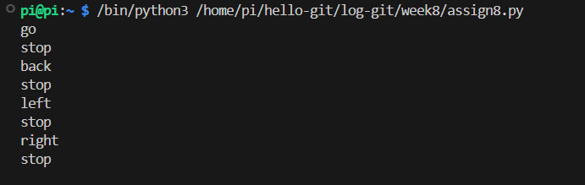

1. 설명

Serial_thread 함수로 블루투스 데이터를 수신해 gData에 저장하도록 하였다.

또한 main 함수에서 gData 값을 확인해서 매핑한 B0~4가 입력되면 해당하는 함수 forward, backward, left, right, stop을 호출하도록 하였다.